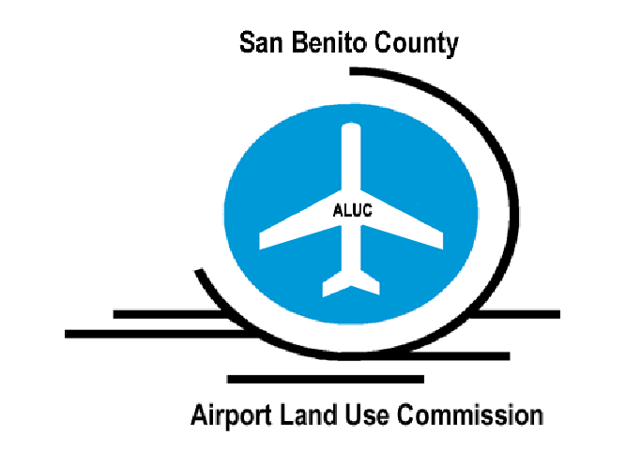
San Benito County
AIRPORT LAND USE COMMISSION (ALUC)
APPLICATION for determination of consistency
Frazier Lake airpark

San Benito County Airport Land Use Commission (ALUC) Overview

The San Benito County Airport Land Use Commission (ALUC) reviews development proposed within the Frazier Lake Airpark’s Airport Influence Area (AIA). Applications are reviewed in compliance with the policies set forth in the adopted Frazier Lake Airpark Comprehensive Land Use Plan.

The Frazier Lake Airpark Comprehensive Land Use Plan is intended to protect public health, safety, and welfare by ensuring the orderly expansion of airports and the adoption of land use measures that minimize the public’s exposure to excessive noise and safety hazards within areas around the airport to the extent that these areas are not already devoted to incompatible uses.

Applications shall include the following information:

Local Agency Information:

San Benito County Local Agency Planner: __________________________

Applicant information:

Applicant Name:
Company Name:
Address:
Telephone Number:
Email:

Property owner information:

Owner's Name:
Address:
Telephone Number:
Email:

Project Information:
PLN File Number
Assessor’s Parcel Number (APN):
Project Address:

Application Attachments:
Description of proposed project:
- General Plan Designation (i.e. Agriculture, commercial, residential, etc.)
- Zoning designation (i.e. Agriculture Productive, etc.)
- Description of the current use and proposed use
- Maximum number of people on the site at any one time. Area (in acres or sq. ft.) of the parcel.
- Identify lighting, glare, heat/steam/vapor/dust, wildlife attractants, water retention ponds etc.
Site Plan showing ground elevations, location and height of structures including roof elements, height of landscaping at maturity, and open spaces.
Location of the project based on the County GIS mapping system at a scale of at least 1:72,224, See: https://gis.cosb.us/Html5Viewer_2_0/Index.html?configBase=https://gis.cosb.us/Geocortex/Essentials/REST/sites/SBC/viewers/Public/virtualdirectory/Resources/Config/Default
Location of the project based on the County GIS mapping system, in relation to the airport safety zones.
Location of the project based on the County GIS mapping system, in relation to the airport noise contours.
Location of the project based on the County GIS mapping system, in relation to the airport FAR Part 77 surfaces
Copies of any environmental document required by the California Environmental Quality Act (CEQA)
and/or the National Environmental Policy Act (NEPA)
Payment according to ALUC’s adopted Fee Schedule ($300)

Application Process:

The Airport Land Use Commission reviews applications for compliance with the criteria and policies set forth in the Comprehensive Land Use Plan. For a copy of these Plan, please visit the Council of Governments’ website at www.SanBenitoCog.org.

Upon final review, the Airport Land Use Commission may find a project either 1) Consistent with Comprehensive Land Use Plan or 2) Inconsistent with the Comprehensive Land Use Plan.

An application shall be deemed complete upon receiving all information requested by ALUC staff. The Airport Land Use Commission must take action on a request for a consistency determination within 60 days of the application deemed complete by ALUC staff. If the determination is not made within 60 days, the project is considered consistent with the Comprehensive Land Use Plan.

Application Submittal:

Veronica Lezama, Transportation Planner
San Benito County Airport Land Use Commission (ALUC)
Phone: 831-637-7765 Ext. 204
Email: veronica@sanbenitocog.org

